This is the latest version
*** *** *** *** *** *** *** *** *** *** *** *** *** *** *** *** *** *** *** *** *** *** *** *** **
*** *** *** *** *** *** *** *** *** *** *** *** *** *** *** *** *** *** *** *** *** *** *** *** **

A comprehensive analysis of the reusability of public omics data across 6 million research publications

Note: The author's name is unsorted for now.

Nicolae Drabcinski^
Department of Computers, Informatics and Microelectronics, Technical University of Moldova, Chisinau, 2045, Moldova
nicolae.drabcinski1@lt.utm.md
ORCID: https://orcid.org/0009-0008-4381-836X

Viorel Munteanu^
Department of Computers, Informatics and Microelectronics, Technical University of Moldova, Chisinau, 2045, Moldova
Department of Biomedical Sciences, College of Medicine and Biological Sciences, University of Suceava, Suceava, Romania, 720229, Romania
viorel.munteanu@lt.utm.md
ORCID: https://orcid.org/0000-0002-4133-5945

Nicholas Darci-Maher
Computational and Systems Biology, University of California, Los Angeles, 580 Portola Plaza, Los Angeles, CA 90095, USA
Email: niko.darcimaher@gmail.com
ORCID: https://orcid.org/0000-0002-8124-030X

Pooja Jaiswal
School of Pharmacy, University of Southern California, 1985 Zonal Avenue, Los Angeles, CA 90089, USA
Email: pjaiswal@usc.edu
ORCID: https://orcid.org/0009-0000-7957-3116

Grigore Boldirev
Department of Computer Science, College of Art and Science,
Georgia State University,
Atlanta, GA, USA
Email: gboldirev1@student.gsu.edu
ORCID: https://orcid.org/0009-0008-8305-1650

Malak S. Abedalthagafi*
Department of Pathology and Laboratory Medicine,
Emory University Hospital,
Atlanta, GA, USA
malak.althgafi@emory.edu
ORCID: https://orcid.org/0000-0003-1786-3366

Alex Zelikovsky*
Department of Computer Science, College of Arts and Sciences,
Georgia State University, Atlanta, GA, 30303, USA
Department of Biomedical Sciences
College of Medicine and Biological Sciences
University of Suceava, Suceava,
Romania, 720229, Romania
Email: alexz@cs.gsu.edu
ORCID ID: https://orcid.org/0000-0003-4424-4691

Serghei Mangul*
Małopolska Centre of Biotechnology, Jagiellonian University, Kraków, Poland
Department of Biological and Morphofunctional Sciences, College of Medicine and Biological Sciences, Stefan cel Mare University of Suceava, Suceava, 720229, Romania;
Department of Computers, Informatics, and Microelectronics, Technical University of Moldova, Chisinau, 2045, Moldova
Department of Computational Biology, School of Digital Public Health, Mohamed bin Zayed University of Artificial Intelligence, Abu Dhabi, UAE
Department of Clinical Pharmacy, Alfred E. Mann School of Pharmacy and Pharmaceutical Sciences, University of Southern California, Los Angeles, CA 90089, USA
Email: serghei.mangul@gmail.com
ORCiD: https://orcid.org/0000-0003-4770-3443

Abstract
In recent years, the scientific community has accumulated vast amounts of omics data, typically stored in specialized public repositories, sparking a profound discussion in the biomedical community about the role of secondary data analysis. Access to this data is essential for efficient re-analysis, novel experiment design, comprehensive meta-analyses, ensuring reproducibility, and driving new biological discoveries. However, the extent and patterns of secondary analysis remain largely unexplored, and the characteristics that make data amenable to reuse remain largely undefined. To address this, we analyzed the reusability of public omics datasets by examining over nine million (9,970,074) open-access publications from 2001 to 2026, to identify key factors influencing data reuse and to improve data sharing practices. Within this dataset, we identified 289,136 omics-based publications, with 65% derived from the reuse of publicly available omics datasets. Notably, we observed a significant disparity between primary and secondary analysis, particularly since 2015, there has been a marked ~5% increase in publications based on the reuse of gene expression data, overtaking those using novel gene expression and RNA-Seq data. This trend marks a notable shift from earlier years when primary analyses predominated, highlighting the growing relevance of utilizing existing datasets. Our analysis reveals that datasets requiring minimal computational resources or advanced bioinformatics methods for analysis tend to have higher reusability rates. We introduce a novel metric, namely ‘reusability index’, to measure the impact of publicly available data. Applied to our dataset, this metric shows that over 100,000 instances of omics data have been reused an average of ten times per year, with at least 40% of the data being utilized at least once. Overall, our analysis provides novel insights into the expanding scope of omics data, providing empirical evidence of the growing significance of secondary analysis and identifying methodological inconsistencies across different omics data types. Additionally, we present an interactive web version of our analysis, facilitating easy exploration and further supporting ongoing research initiatives.
Introduction
Over the two decades, the decrease in high-throughput sequencing costs has led to a rapid increase in the generation and storage of omics data in public repositories [CITE]. Emerging evidence underscores the critical role of data sharing in driving discoveries across various biomedical disciplines. Centralized repositories with data in easy-to-use formats, enable researchers to re-analyze and reinterpret the data thereby facilitating new biomedical discoveries^{1,2}. Such practices promote transparency, reproducibility, and collaboration within the research community. Despite its numerous advantages and crucial role, secondary analyses of previously published data are frequently perceived as less impactful. Furthermore, there is limited literature discussing both the advantages and limitations of re-analyzing the data.^{2-4,30,31}

The traditional research involves generating, analyzing, and interpreting large and diverse datasets to address specific research questions and to validate or challenge initial hypotheses. Notably, many datasets, initially designed for specific purposes, can also provide insights into related, yet distinct, research questions, revealing broader patterns that emerge only through the accumulation of multiple studies. This initial analysis, known as primary analysis, forms the foundation of scientific inquiry.^{5,6} Sharing primary data through centralized repositories in user-friendly formats facilitates easy access and re-analysis of raw data, thereby fostering transparency and collaboration within the scientific community⁷. Instead of generating new data in the lab, which is usually time-intensive, necessitates extensive planning, and incurs high costs, an increasing number of researchers tend to analyze existing data to test new hypotheses or to gain alternative perspectives on original questions.⁸ As the biomedical community continues to explore and extend the boundaries of these practices, the ‘reusability’ term takes on new dimensions, opening novel frontiers for exploration and innovation. This approach, known as secondary analysis, unlocks new insights by leveraging publicly available omics datasets, thereby catalyzing discoveries in the biomedical field.
Increasing evidence suggests that secondary analysis has the potential to facilitate novel biological discoveries across multiple scientific fields.³⁻⁶ The ability to re-analyze aggregated data from various populations, diseases, and phenotypes can unveil hidden patterns and associations that might not have been apparent in individual studies. For instance, in genetics, the secondary analysis of genomic data across diverse populations has led to the identification of genetic variants associated with complex diseases like diabetes, Alzheimer's disease, and cancer.⁹ Moreover, in epidemiology, the aggregation of data from diverse disease cohorts has enabled researchers to identify risk factors and patterns of disease spread, contributing significantly to the development of targeted public health interventions. Additionally, secondary analysis presents a cost-effective approach, particularly beneficial for resource-limited countries and institutions.¹⁰ To enable effective secondary analysis, it is imperative that datasets are easily discoverable, downloadable, and accompanied by comprehensive metadata to ensure accurate interpretation and contextualization of results.^{11,12} However, there is still a lack of knowledge regarding the current scale of secondary analysis, the types of most valuable omics data types utilized, and the factors that contribute to a dataset's reusability.

Here, we present a comprehensive analysis of the reusability of public omics datasets across four million open-access publications spanning from 2001 to 2026. We identified a total of 276,642 publications that included both primary and secondary analyses. Among these, 35.3% were classified as primary analysis publications, 64.7% as secondary analysis publications, and 3.9% encompassed both primary and secondary analysis. We found that two-thirds of the 276,642 omics publications analyzed were based on secondary analysis, with a consistent annual increase of 10% in the proportion of such studies since 2004. We have conducted a comparative analysis of reusability practices across different omics data types, shedding light on the frequency of reuse for various dataset categories. Remarkably, since 2015 the number of publications that perform secondary analysis exceeds the number of publications that contain primary analysis of gene expression array data. On the other hand, despite a 35% increase in secondary analysis studies of RNA-Seq data since 2009, the majority of papers are still focusing on primary analysis through 2022.
In our study of omics data reusability, we considered a spectrum of cutting-edge technologies and data repositories. For instance, RNA-Seq data, a cornerstone of transcriptomic analysis, was sourced from multiple repositories including the Gene Expression Omnibus (GEO) and the Sequence Read Archive (SRA). GEO hosts diverse high-throughput functional genomic datasets spanning microarray-based studies and RNA-Seq experiments, while SRA specializes in raw sequencing data from next-generation sequencing (NGS) platforms, including RNA-Seq. By leveraging both GEO and SRA, we ensured comprehensive coverage of RNA-Seq data, enabling us to capture a diverse spectrum of transcriptomic profiles and study designs. Our analysis also encompassed other omics data types stored across various repositories, ensuring a broad representation of publicly available datasets.
It is crucial to highlight the current lack of a universal index capable of accurately estimating the reusability of public genomics datasets. The main challenge stems from the inadequacy of existing methods, particularly the reliance on citation counts as a metric for assessing dataset impact. Notably, relying solely on citation metrics may not capture the comprehensive measure of a dataset’s reusability, as it fails to account for the full spectrum of dataset utilization. Citations predominantly capture the initial attention a dataset receives upon its publication, overlooking subsequent reuses and broader impacts. Therefore, the limitations of citations underscore the necessity for a more refined and dynamic metric to assess research impact. To address this gap, we propose a novel reusability index that more effectively measures the impact of publicly available data. Our proposed index offers a more effective alternative to traditional citations, by evaluating a dataset's influence through its relevance and usage over time. As evidence of its significance, we observe that over 100 thousand omics datasets have been reused at least once, highlighting the necessity for a more refined metric to accurately capture the true reusability and impact of publicly available genomics datasets. Since 2015, there has been a notable shift in the trend of research publications, with approximately 5% more research papers prioritizing secondary analysis over primary analysis. This represents a notable shift from previous years when primary analysis was more prevalent. In light of the encouraging progress toward data reusability, a substantial portion of data remains untapped. Specifically, our analysis reveals that 21% of RNA-seq data from GEO, 31% of Gene Expression Array data, 3% of RNA-seq data from SRA, and a significant 45% of other NGS data from SRA have not yet been employed in further studies.
We categorized our dataset into four distinct groups, each encompassing a different range of data sources. These categories include Microarray Gene Expression Data (MGED), RNA-seq gene expression data (RSGED), RNA-seq in SRA data (RSRA), and Whole Genome Sequencing in SRA (WGSRA). This categorization ensures a comprehensive representation of various data types, allowing for a more thorough analysis and understanding of the datasets.
This approach facilitated a holistic examination of omics data reusability trends, shedding light on the factors influencing dataset utilization and impact across different technological platforms and repositories.
Results
Assessing the reusability of public omics data
To quantify the reusability of public omics datasets archived in NCBI database, we downloaded a comprehensive dataset of scientific publications spanning from 2001 to 2024, comprising 5,547,235 open-access articles with full texts available via PubMed. Using the SRA and GEO accession ID’s mentioned in the text, we identified a total of 326,177 publications as either primary or secondary analyses in omics-based studies where we explain what data we consider. The publication's lack of differentiation between primary and secondary studies necessitates reliance on the date of publication.aID mentioned in the text, we identified a total of 326,177 publications as either primary or secondary analyses in omics-based studies where we explain what data we consider. The publication's lack of differentiation between primary and secondary studies necessitates reliance on the date of publication. To address this issue, we developed a tailored method that utilizes publication dates to differentiate between primary and secondary analysis publications. We considered primary analysis as publications that generated novel omics datasets and secondary analysis as those utilizing previously produced omics data (Figure S1). We designated the earliest-published reference to a dataset as the primary analysis, while subsequent publications were considered to perform secondary analysis. In our study of omics data reusability, we considered a spectrum of cutting-edge technologies and data repositories. This approach facilitated a holistic examination of omics data reusability trends, shedding light on the factors influencing dataset utilization and impact across different technological platforms and repositories. We conducted filters using SRA or GEO accession ID patterns to correlate publications with the content of the repository. To ensure the accuracy of our approach to differentiate primary and secondary analysis, we validated our approach based on a curated gold-standard dataset. We randomly selected 1000 publications from the full set of omics-based studies, The validation process revealed a classification accuracy rate of 97.6% TP (488 out of 500) for Primary analysis and 97.4% TP (487 out of 500) for Secondary analysis, with the remaining 2.4% and 2.6% attributed to FP misclassifications, respectively. These misclassifications may be attributed to factors such as the unavailability of full text for specific publications in the NCBI database or datasets shared in pre-print journals where accession numbers of publications are not included in the metadata.
Omics Data Trends: Exploring the Balance Between Primary and Secondary Analysis
The proportion of secondary analysis publications surpasses that of primary analysis publications, with a notable 29.4% difference. Specifically, 65% of the publications fall under the category of secondary analysis, while 35% are classified as primary analysis( Figure 1).
We next analyzed the types of omics datasets mentioned in the publications. Out of the 276,643 primary and secondary analysis publications, 102,357 studies referred to microarray gene expression in GEO datasets, 71,924 studies mentioned RSGED, 69,160 studies referenced multiple types in SRA datasets, and 23,053 studies mentioned RSRA (Figure 2). Notably, publications mentioning RSSRA datasets had a higher proportion of secondary analysis than those referencing other SRA datasets (Figure 3).

The number of studies using secondary analysis has increased over the years
The trend analysis of secondary analysis across various omics datasets reveals intriguing patterns over time. Specifically, the proportion of publications conducting secondary analysis on Microarray Gene Expression datasets has witnessed a consistent upward trajectory, starting at approximately 10% in 2005 and steadily increasing to a remarkable 85% by 2022 (Figure 4A). In contrast, secondary analysis publications utilizing RNA-seq gene expression data (RSGED) and RNA-seq in SRA data (RSRA) exhibited a slower pace of growth, evolving from about 5% in 2009 to approximately 35% by 2022 (Figure 4B and 4C). Meanwhile, the proportion of secondary analysis publications leveraging WGS in SRA data (WGSRA) remained relatively stable, fluctuating between 45% and 65% from 2009 to 2022. These trends underscore the dynamic landscape of omics data utilization, highlighting Microarray Gene Expression datasets as a dominant choice for secondary analysis while demonstrating varying rates of adoption across different omics data types.

Quantify reusability with the Reusability Index (RI) and Normalized Reusability Index (NRI)
We analyzed the impact of datasets by the amount of attention they received after being uploaded to a repository, as opposed to the number of citations a publication receives. To measure this impact, we introduced the novel Reusability Index (RI), which is defined as the total mentions of a dataset minus one. Additionally, we introduced the Normalized Reusability Index (NRI), defined as the RI of a dataset divided by the time in years since its publication date. Despite a few initiatives like ReCount¹³, previous studies have shown that omics datasets are poorly reused. Our findings indicate that over 53% of gene expression data, over 72% of RNA-seq datasets in GEO and SRA, and over 76% of other SRA datasets are not reused even once (RI=0). Gene expression datasets have the highest average RI of 4.77, followed by RNA-seq datasets with an average RI of 2.09, and other SRA datasets with an average RI of 2.01 (Figure 5-A). The average NRI shows less variation across all three categories compared to the average RI, which could be due to Microarray Gene Expression datasets tending to be older than WGSRA and RSRA (Figure 5-B). Gene expression datasets exhibit a notable presence of outliers characterized by exceptionally high RIs, often associated with extensively studied pathologies such as breast cancer. These exceptional datasets, distinguished by RIs in the hundreds and thousands, underscore their significance in the scientific landscape. Importantly, these datasets, though not formally designated as "exemplary cases," manifest sustained and increasing rates of reuse each year since their initial public release, as depicted in Figure 6. This phenomenon emphasizes the enduring impact of select datasets and the varying rates of reuse within the scientific community. (Figure 6).

Key features in the datasets that affect RI and NRI
In this study, we investigated the factors that influence the reusability of omics datasets. Our analysis revealed that human datasets tend to have higher Reusability Indices (RIs) than non-human datasets across all three dataset categories, with the most significant difference observed in gene expression datasets (Figure 7). Based on the median, Homo sapiens, Mus musculus, and Drosophila melanogaster are the species with the highest RI in gene expression and other SRA datasets, while Homo sapiens, Mus musculus, and Arabidopsis thaliana have the highest RI in RNA-seq datasets (Figure 8).
Additionally, we examined the sequencing techniques used in the studies and found that secondary analysis is becoming more popular and has overtaken primary analysis as the preferred method of data acquisition in some contexts such as gene expression arrays. Furthermore, we identified the top 10 libraries used on GEO, RNA-seq, and Other_SRA (Figure 9), and discovered a direct relationship between the number of citations and the number of times a dataset was reused (Figure 10).
RNA-seq in SRA vs Gene Expression
We conducted a comparative analysis of the reuse of RNA-Seq as the same library strategy in gene expression and SRA datasets. The results clearly indicate that RNA-Seq utilization in gene expression significantly surpasses that of the SRA dataset (Figure 12).
Discussion
The findings from our analysis shed light on the varying degrees of reusability observed across different omics datasets, underscoring inconsistent practices in their utilization. Notably, datasets requiring less computational resources or advanced bioinformatics skills demonstrate higher reusability rates. These insights are pivotal in informing policies aimed at fostering effective data reusability and facilitating broader data sharing initiatives. Moreover, our study delves into the prevailing impediments surrounding the secondary analysis of omics datasets and proposes potential remedies. This systematic examination marks the first endeavor to scrutinize the contemporary landscape and evolving trends in omics data secondary analysis^{14,15}.
Our exploration reveals a discernible uptick in secondary analysis, necessitating the development of user-friendly formats to bolster omics data reusability. Historically, the assessment of research impact has predominantly centered on publications unveiling original discoveries, often sidelining the intrinsic value of the datasets themselves¹. Encouraging data sharing aligns with the ethos of scientific progress, emphasizing the reliance on preceding research. While prior literature focuses on access barriers to public omics data and advocates for data sharing, there's a dearth of discourse addressing resource-aware strategies for enabling data reusability. This shift towards promoting data sharing and reuse, now mandated by many funding bodies and journals to ensure reproducibility, presents both opportunities and challenges in managing and integrating heterogeneous data sources¹⁶.
The ability to recycle and amalgamate omics data from multiple studies facilitates meta-analyses and cross-study comparisons, augmenting statistical power and unearthing novel insights unattainable through individual datasets². The indispensability of data sharing and reuse in advancing our comprehension of intricate biological systems is thus underscored.
The value of secondary analyses of omics data hinges largely upon metadata annotations and accessibility constraints, which can either curtail or enrich their utility. Although primary analysis studies traditionally garner more impact, secondary analyses yield substantial merit, particularly when accompanied by comprehensive metadata and accessible data. Despite their numerous advantages, there's a prevalent notion that secondary analysis of previously published data holds lesser impact, with limited exploration into its pros and cons. While secondary analysis doesn't supplant primary analysis, it furnishes valuable insights and is progressively gaining traction. Conventionally, research impact has been gauged solely by the initial publications, often overlooking the inherent worth of datasets. Nonetheless, our categorization based on sequencing techniques—gene expression, RNA-seq, and other SRA revealed significant differences in reusability, favoring gene expression datasets, especially when non-normalizing.
Identifying pivotal attributes of frequently reused omics datasets, such as human-readable formats, substantial sample sizes, species diversity in population studies, and gene expression datasets, proves instrumental. Simultaneously, we've identified barriers inhibiting researchers from conducting secondary analyses, including inadequately curated repositories, limited computational skills, and an underestimation of public omics datasets' value.
To promote secondary analysis easy-to-use repositories or dataset formats can boost data reusability. Datasets should be complete, annotated, and include downstream analysis results where possible. Secondly, the development of computational tools that can resolve the burden of processing raw sequencing files, aggregating omics datasets from different studies, and generating reliable and meaningful metadata would be beneficial. Thirdly, we should break down the stigma surrounding secondary analysis and emphasize its advantages. Fourthly, it is essential to acknowledge the work of those who introduced the data that is reused could be using our newly introduced reusability index. Lastly, managing and making data accessible pose challenges and create added responsibilities in scientific pursuits. A recent meta-analysis highlighted that researchers often face constraints in terms of time, resources, and expertise, hindering their ability to effectively share data²⁷⁻²⁹. Especially in fields with high publication rates, the additional efforts to enable subsequent reanalysis can easily be overlooked. Nevertheless, embracing open data principles equips laboratories and research institutions to offer the necessary depth of information. Furthermore, the adoption of open principles inherently fosters reproducibility by streamlining the steps needed to ensure research replicability¹⁷.
We acknowledge that our analysis has some limitations, such as our focus on the main body of articles and the exclusion of supplementary materials. We also note that our temporal cutoff for removing false positive primary analysis publications was not computationally optimized, but rather based on a set of manually validated gold-standard relationships between papers and the datasets they introduced. However, our method was carefully adjusted to minimize false positives and maximize true positives, and we achieved a TP rate of 98% for our results by manually checking 1000 papers that included primary or secondary analysis.
In conclusion, our study provides empirical evidence that reusing publicly available omics data is effective and currently dominating the landscape of biomedical research, allowing researchers to perform large-scale studies in a cost-effective manner. Secondary analysis represents a fast way to save resources and accelerate novel biological discoveries in the biomedical community. By addressing the barriers to secondary analysis and promoting its advantages, we can encourage more researchers to conduct secondary analysis and achieve impactful scientific discoveries without generating new omics datasets. Furthermore, secondary analysis plays a vital role in advancing science by facilitating novel biomedical discoveries.

Methods
Datasets
The complete content of 5,547,235 open-access publications, published in 27,482 journals between 2001 and 2026, was obtained from the PubMed Central (PMC) year-end 2024 corpus, accessible in Extensible Markup Language (XML) format²⁴. Through text mining, we successfully identified a unique PMC identification number (PMC ID) for each publication, which was subsequently used for accurately linking and cross-referencing the articles with corresponding datasets.
To identify and analyze omics datasets referenced within these publications, we acquired reference tables for the Sequence Read Archive (SRA) and the Gene Expression Omnibus (GEO) datasets were acquired by accessing the NCBI public Application Programming Interface (API) directly in Comma Separated Value (CSV) format on February 20, 2026. This API retrieval offered comprehensive metadata for each dataset, including accession numbers, enabling efficient and accurate data handling for our research.
To identify SRA and GEO accession numbers mentioned in the main text of publications, we employed regular expressions¹⁵, specifically searching for SRA accessions with the following prefixes, followed by 6-7 digits: "SRA", "SRP", "SRX", "SRR", "SRS", "SRZ", "DRA", "DRP", "DRX", "DRR", "DRS", "DRZ", "ERA", "ERP", "ERX", "ERR", "ERS", "ERZ", "PRJNA". Similarly, GEO accessions were identified by searching for the following prefixes, followed by 1-7 digits: "GDS", "GDE", "GDL", "GSS", "GSE", "GSL", "GPS", "GPE", "GPL". In total, we identified 289,136 publications that mentioned at least one SRA or GEO dataset. Due to limited access, Supplementary Materials for PubMed publications were not parsed.
To account for potential duplication of data stored in both GEO and SRA repositories, we utilized a gold-standard dataset derived from refine.bio repository¹⁸⁻²⁰. Simple deduplication by unique accession number is insuficient, as the same underlying dataset in pretty often archived in both repositories under distinct identifier schemes. For example, a single study may be assigned a GEO Series accession while its raw sequencing files are indexed in SRA under a separate Study accession. Filtering by unique IDs alone would therefore treat these as independent datasets, artificially inflating dataset counts and misclassifying reuse values. This dataset contains information for all datasets present in both repositories, including their corresponding GEO and SRA accession numbers. By mapping the SRA ID of each duplicate dataset to its corresponding GEO ID, we successfully eliminated duplicate entries from our analysis.
We categorized the datasets into four distinct groups: (1) Microarray Gene Expression Data (MGED), which included all non-RNA-seq datasets from GEO (65,961 datasets); (2) RNA-Seq Gene Expression Data (RSGED), comprised of RNA-seq datasets from GEO, and (3) RNA-seq in SRA (RSRA), which included all primary RNA-seq datasets from SRA, andWhole Genome Sequencing in SRA (WGSRA) encompassing all remaining NGS datasets from SRA. The aggregated dataset will contain metadata and reusability metrics for all publications and datasets, will be made public available for future researches in omics data reusability.
Extracting metadata associated with selected publications
Publication metadata was extracted from the XML files of selected articles, including: PMC identifier, DOI, title, abstract, journal name, author list, and earliest recorded publication date. from selected publications was extracted by generating a key file containing the paths to every XML file of publications mentioning SRA or GEO.Automated Python-based pipeline, utilizing the ElementTree package^{21,22,23} systematically extracted publications metadata from these files. The script identified the earliest publication date listed in each file and recorded it as the publication date..
Obtaining citation counts
… (Replaced with OpenAlex)

Consolidating data
We made publicly available a processed version of our dataset: a csv.zip file (3,904,746 papers, 3 GB) including PMID, title, journal name, publication year, etc. It can be downloaded from (https://github.com/Mangul-Lab-USC/omics-data-reusability). The results of parsing text and XML with public records of SRA and GEO datasets were combined to generate a table that included relationships between PMC ID and SRA/GEO accession numbers, publication dates, SRA and GEO dataset metadata from NCBI, Each row of the table represented a unique PubMed publication-dataset accession number relationship. To avoid false positives, dataset accession numbers that were not present in the NCBI metadata tables were removed from the analysis. Also, dataset accession numbers that were present in the NCBI metadata tables but not in the results were removed because there was no record of an associated publication.
Single studies in SRA and GEO were stored in multiple virtual objects, each with a unique accession number. These objects could be as small as a single sequencing run (e.g., SRR6186127) or as large as all the data associated with one study (e.g., SRP120276). To address the problem of publications citing different accession numbers for the same data, the tables downloaded from NCBI were used to convert every SRA accession number to its associated SRA Study and every GEO accession number to its associated GEO Series.
NCBI reference tables were also used to associate dataset accession numbers with species, technology, and publish date. The number of times each dataset was reused was counted after converting dataset accession numbers. The metadata factors of interest were sequencing hardware, library strategy, species, number of samples (SRA only), and access restrictions (SRA only). Although library strategy information was missing for GEO datasets, two GEO library strategy categories using hardware information were present: "Expression Array" (including hardware entries like "in situ oligonucleotide" and "oligonucleotide beads") and "RNA-seq" (including hardware entries like "high-throughput sequencing").
Classifying publications into primary and secondary analysis
In order to distinguish between primary and secondary analyses for each publication-dataset relationship, the earliest-published publication that mentioned a given dataset was labeled as primary analysis, while any subsequent publications were labeled as secondary analysis. To ensure the accuracy of these labels, the dates of publication for each publication were compared to the dates that their corresponding datasets were made public. Publications that were labeled as primary analysis but were published more than 270 days before or after the date of data upload were removed from the analysis, as it was assumed that these publications had conducted secondary analysis on data from a publication that had no record. This threshold of 270 days was chosen based on the assumption that it was far greater than the reasonable time delay between publication and data upload.
Reusability Index
In order to calculate the reusability Index (RI), the total number of unique publications in which a dataset was mentioned was counted. The RI was obtained by counting the number of publications that reuse the dataset. To compute the Normalized Reusability Index (NRI), we divided the RI by the number of years since the data's initial public release
Reusability website:
We utilized Streamlit and other Python technologies to ensure reusability in our website implementation. By eliminating nuisance parameters, we created a clean and user-friendly interface for inputting data. All data and metadata are stored in the database, providing users the option to utilize a filter mode. Users can effortlessly navigate and locate specific data using parameters such as repository, date, or type. To maintain metadata about dataset usage, we've adopted a two-tiered approach: the first tier displays datasets with usage details, while the second tier enables users to select specific datasets for a more detailed view. Our website showcases results in both graphical and textual formats. The most significant metadata is visually depicted as consensus sequences on the primary results page. Additionally, a table presents summary statistics for each result, while further comprehensive study information is presented in text format below. This section elaborates on entropy scores in the iterations, providing a comprehensive view of the study's insights (refer to Figure 7).

Acknowledgments
We also want to thank our colleagues at the University of Southern California for their helpful feedback and support. In particular, we would like to thank Dr. JungHyun Jung and XXX for their invaluable contributions to our research.

Code Availability
All of the scripts that developed for reusability results are freely available at https://github.com/Mangul-Lab-USC/omics-data-reusability. The Reusability is distributed under the terms of the General Public License version 3.0 (GPLv3). All code required to produce the figures and analysis performed in this paper is freely available at https://github.com/Mangul-Lab-USC/omics-data-reusability
Data availability:
All data required to produce the figures and analysis performed in this paper are freely available at https://github.com/Mangul-Lab-USC/omics-data-reusability
Funding
MV, NDM, JB, KP, AR, DY, KCH, PJ, SS, AS are supported by the National Science Foundation (NSF) grants 2041984, 2135954 and 2316223 and National Institutes of Health (NIH) grant R01AI173172

Figures

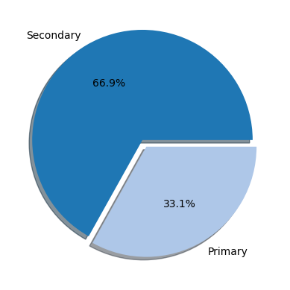
Figure 1. Percentage of papers mentioning each type of reuse. Out of 218,789 publications after filters, 72,419 (33%) primary analysis and 146,369 (67%) secondary analysis.
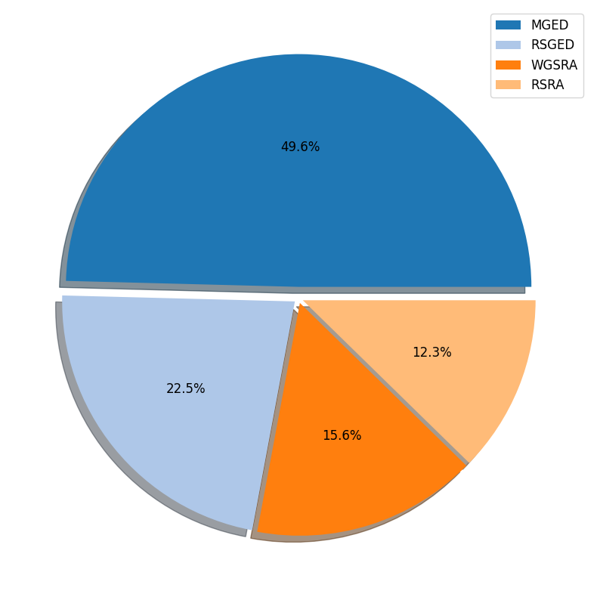
Figure 2. Out of 218,789 publications, half of the studies (108,519) referred to Microarray Gene Expression Data (MGED), 23% (49,228) mentioned RNA-seq gene expression data (RSGED), 16% (34,134) referenced Whole Genome Sequencing in SRA data (WGSRA), and 12% (26911) mentioned RNA-Seq in SRA data (RSRA).

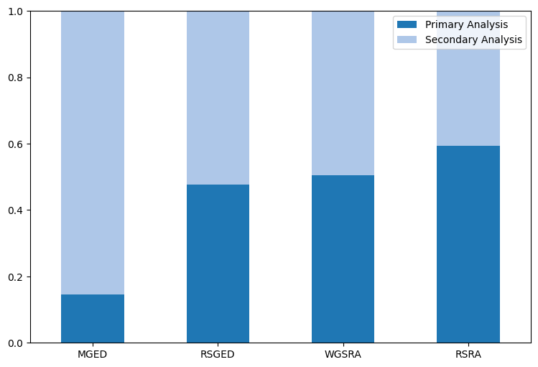

Figure 3. Role of Papers Mentioning Different Types of Sequencing Data in Reuse
This figure illustrates the distribution of primary and secondary analyses in publications mentioning various omics repositories. Publications that referenced gene expression datasets showed a higher ratio of secondary analysis compared to those mentioning other Sequence Read Archive (SRA) datasets. The left bar corresponds to publications mentioning Microarray Gene Expression data (MGED), the second bar represents those mentioning RNA-seq gene expression data (RSGED), the third bar represents those mentioning Whole Genome Sequencing in SRA data (WGSRA), and the right bar represents publications mentioning RNA-seq in SRA data (RSRA).

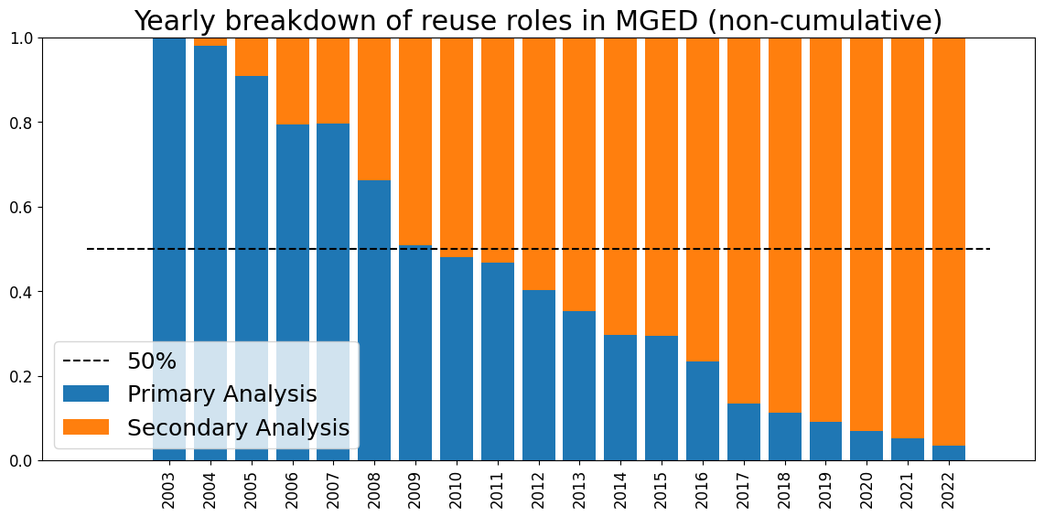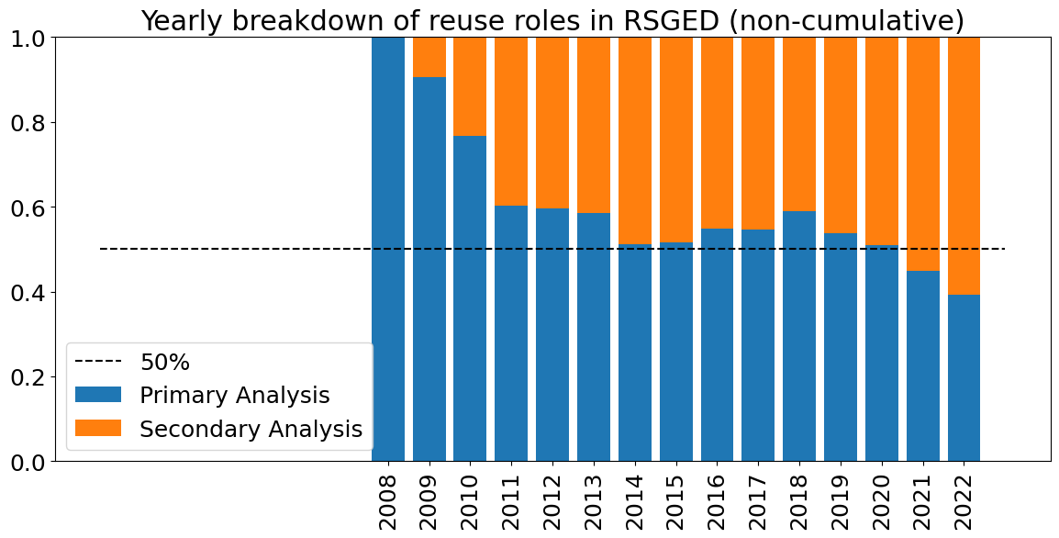
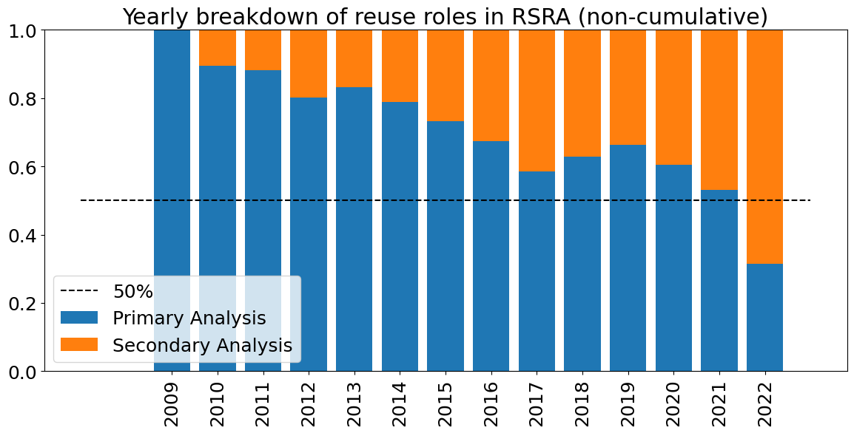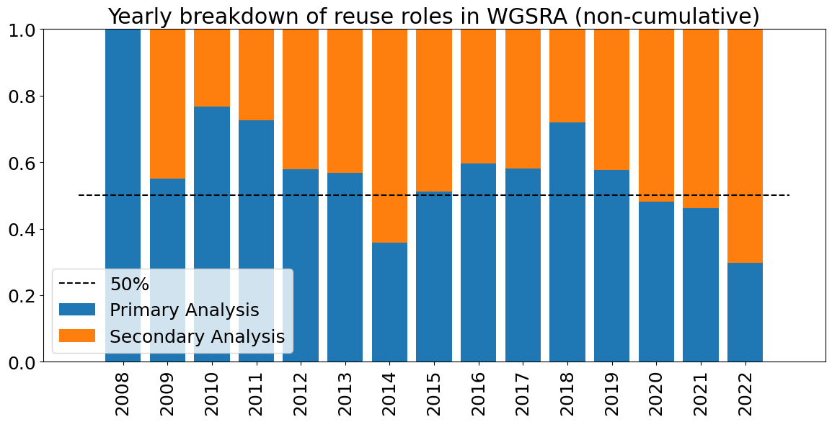
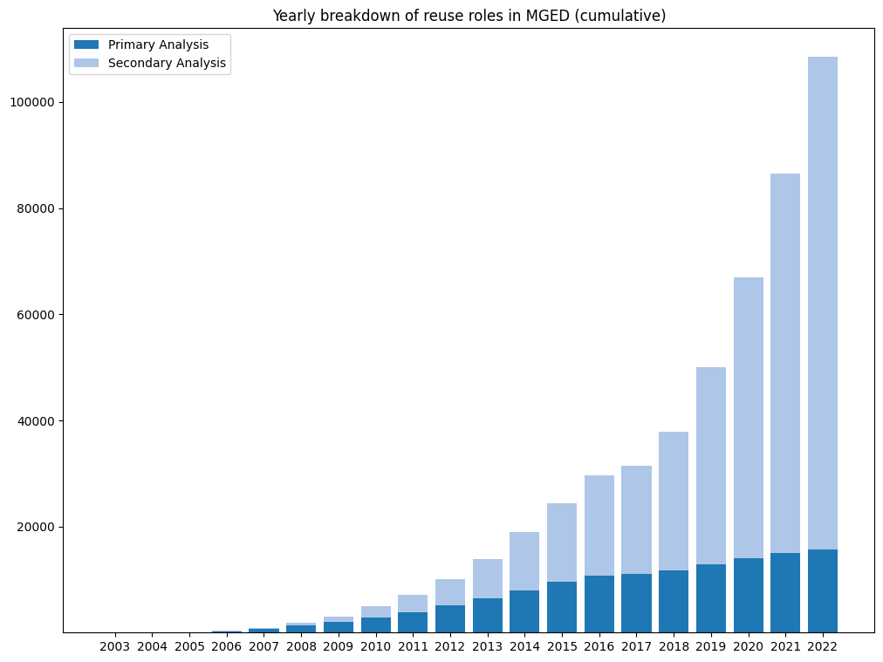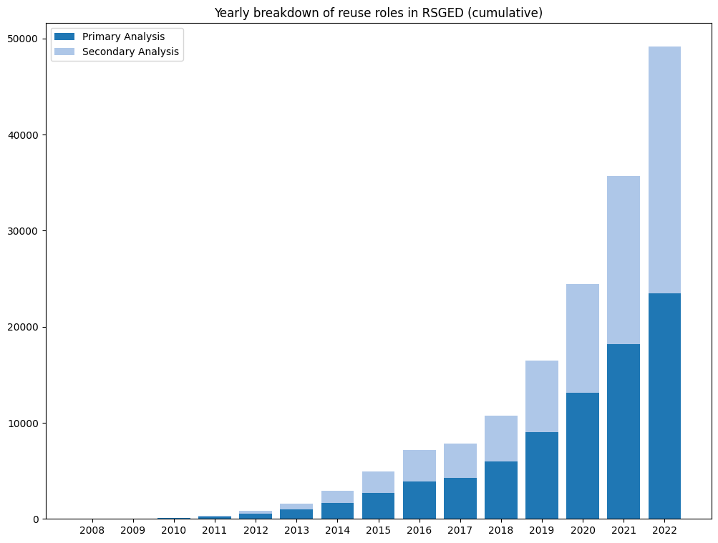
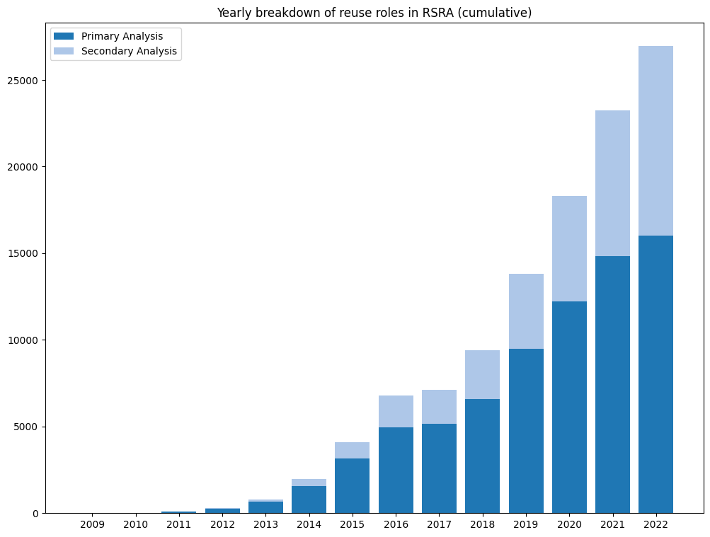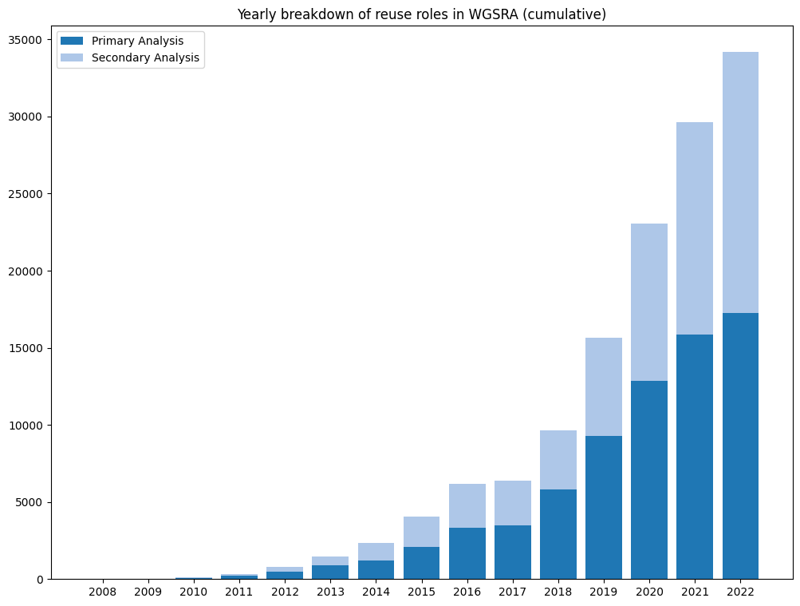

Figure 4. Represents yearly breakdown of reuse roles (Non-cumulative/cumulative) in four groups. The Top-left Microarray Gene Expression Data (MGED), The top-right plot represents those mentioning RNA-seq gene expression data (RSGED), The down-left plot represents those mentioning WGS in SRA data (WGSRA), and The down-right plot represents publications mentioning RNA-seq in SRA data (RSRA). Plots top are non-cumulative / Down cumulative.

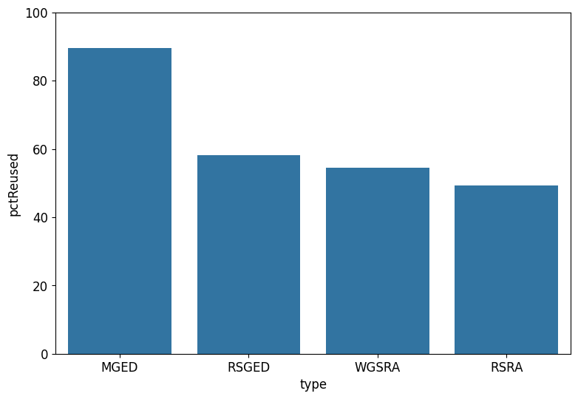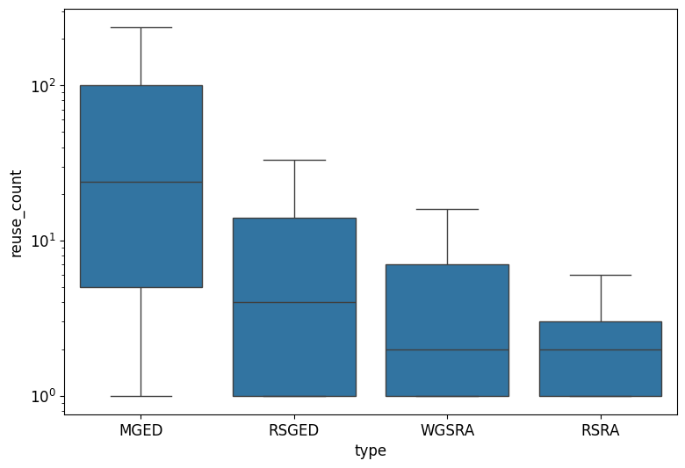
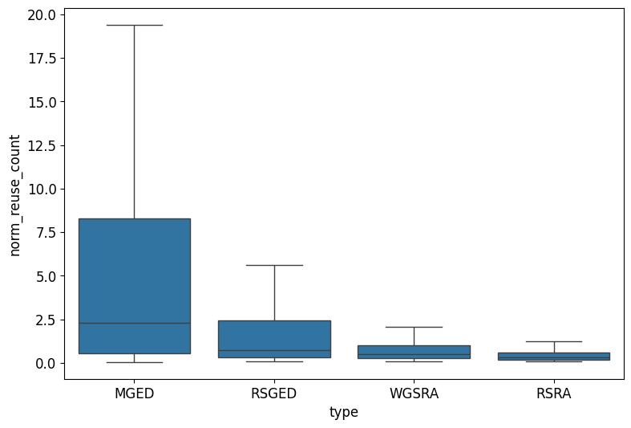

Figure 5. The first bar plot represents the percentage of datasets reused, and the second bar plot represents the distribution of reused datasets (after 2008). The last barplot represents the distribution of the normalized reused index datasets, by time from each category.

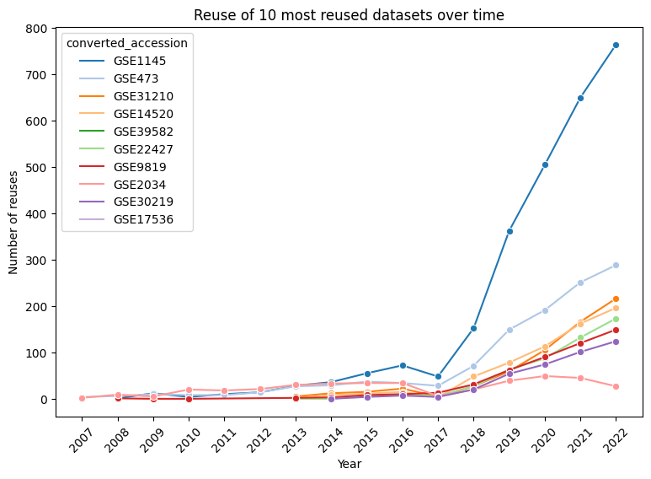

Figure 6. Represents the 10 most reused datasets between 2007 ~ 2022. All of them are Microarray Gene Expression Data (MGED).

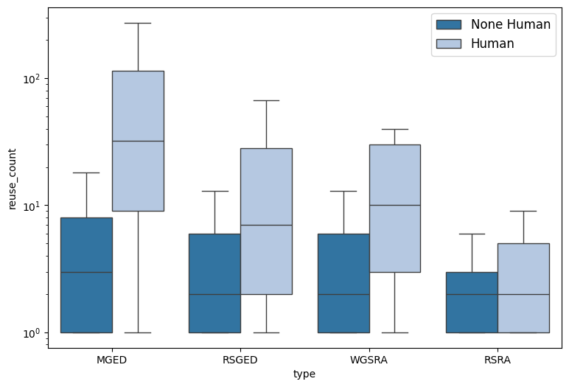

Figure 7. Represents the distribution of reused human versus nonhuman datasets.

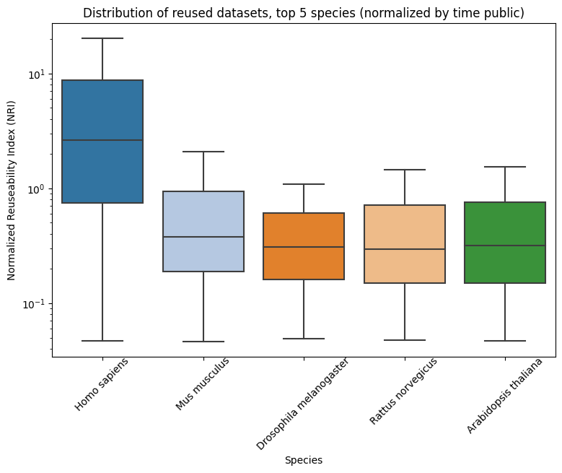
Figure 8. Based on the median, Homo sapiens, Mus musculus, and Drosophila melanogaster are the species with the highest NRI in gene expression and other SRA datasets.

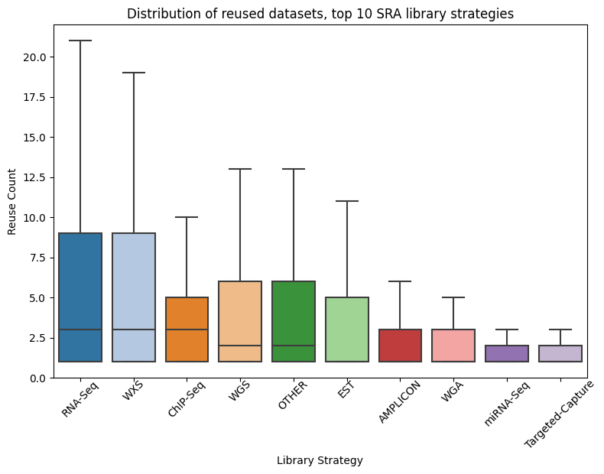
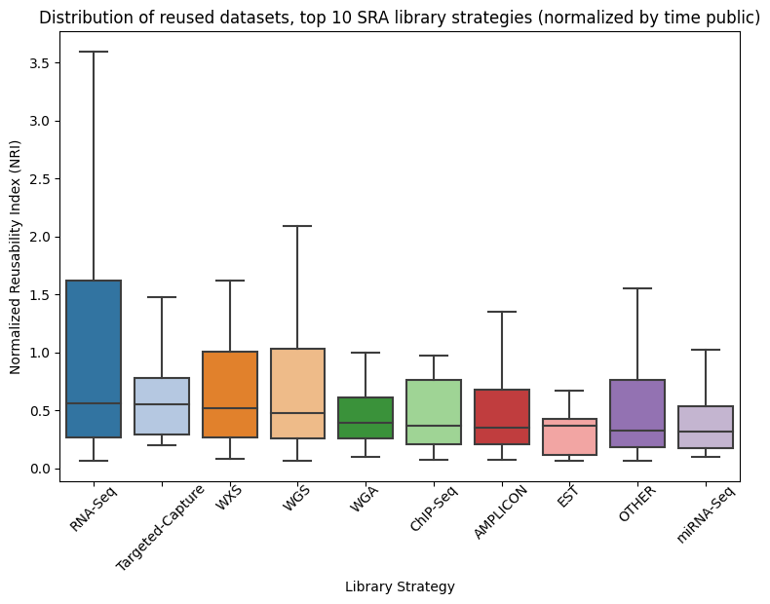
Figure 9. Distribution of reused library strategies in SRA. Top 10 technologies to make SRA data that were non-normalized/normalized.

(A)
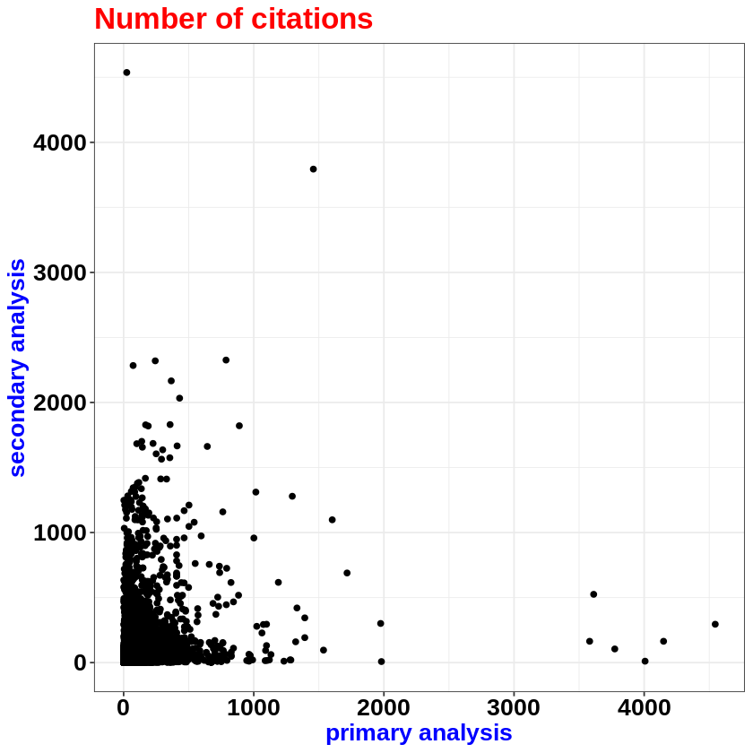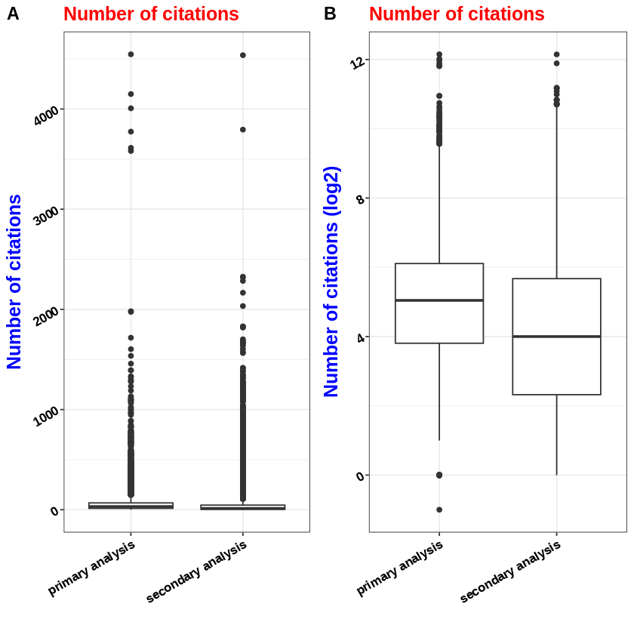

Figure 10. Number of citations for studies. (A) The number of primary analysis vs. secondary analysis of citations. (B) The number of primary analyses of citations vs. secondary analysis.

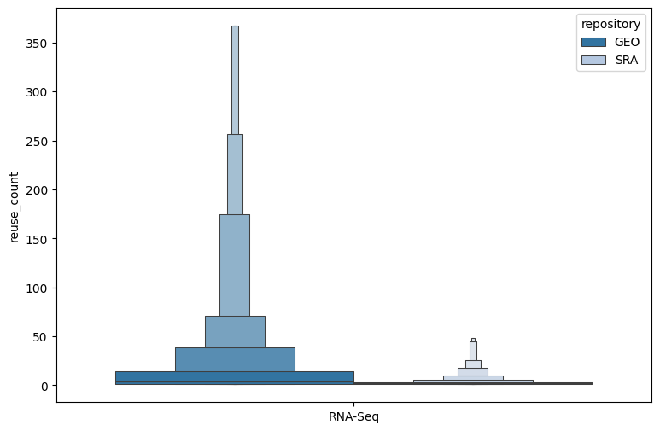
Figure 11. The number of Reuse RNA-Seq in Gene Expression and SRA.

Supplementary Figures
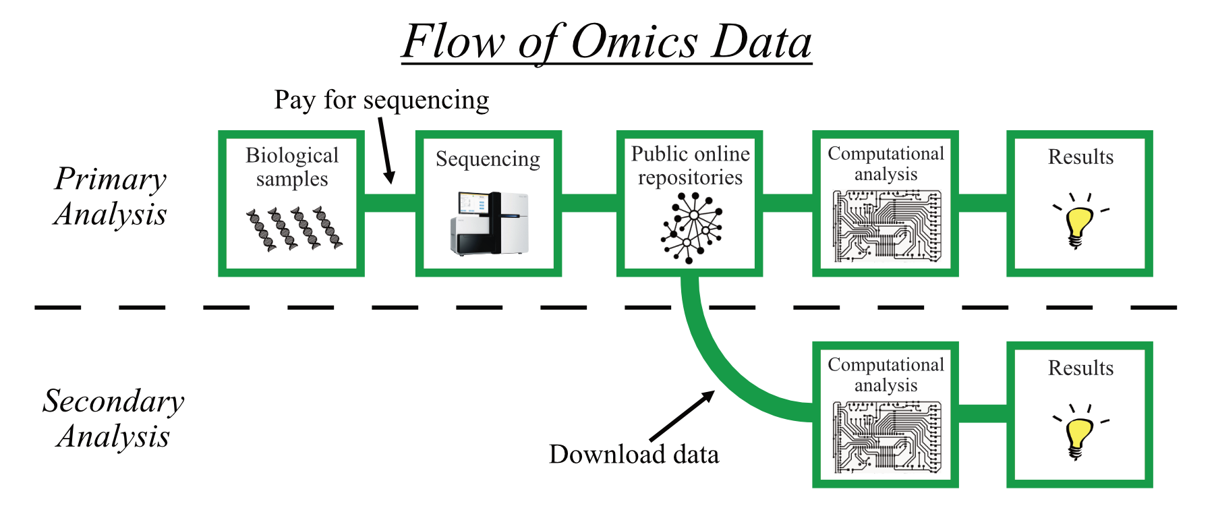
(Figure S1) Caption: Schematic representing the process of producing omics results. The top half of the figure depicts the method of the primary analysis, starting from raw biological samples and concluding with published results. The bottom half of the figure depicts the method of secondary analysis, starting from previously produced data downloaded from a repository, and concluding in published results.

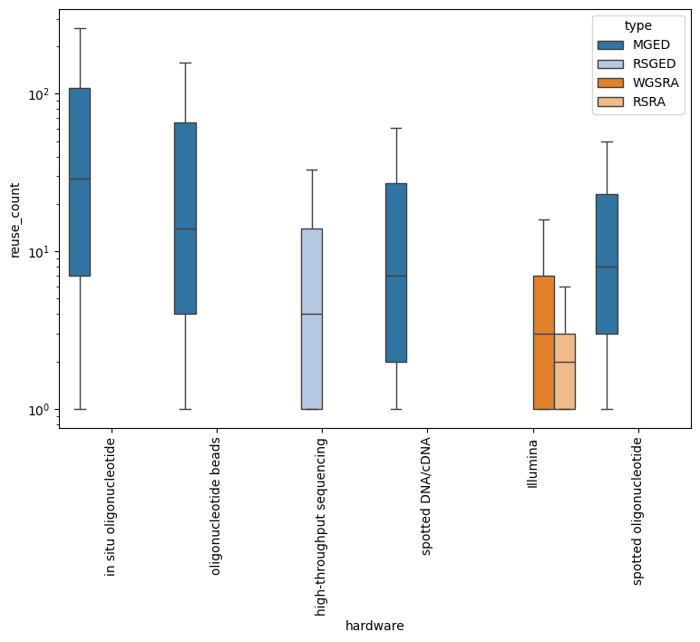
(Figure S2) Caption: Distribution of reused datasets, top 6 types of sequencing hardware. “Illumina” technologies (combined all Illumina technologies types) are used to get both RNA-Seq and WGS in SRA, “high-throughput” sequencing is used to get RNA-seq gene expression data, and other ("in situ oligonucleotide", "oligonucleotide beads" and “spotted DNA/CDNA”) used for get Microarray Gene Expression Data.

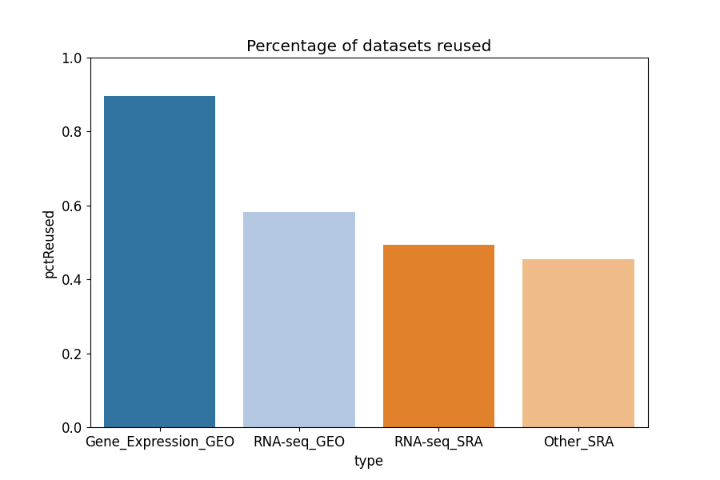

(Figure S3) Percentage of proportion of datasets reused. Result of comparing the number of datasets that were mentioned in more than one unique publication to the total number of datasets included in our analysis. The left bar represents gene expression datasets. The middle bar represents RNA-seq datasets. The right bar represents other SRA datasets.
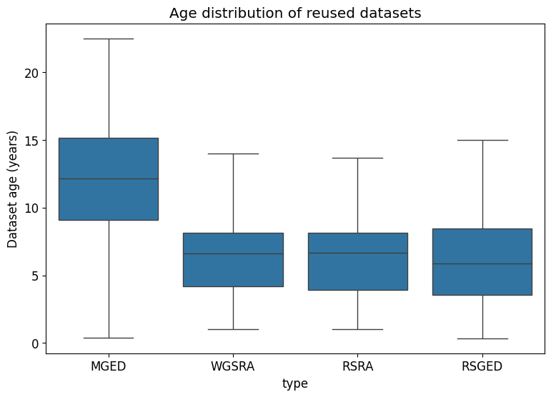
(Figure S4) Reuse distribution of reused datasets. Distribution of the RI of reused datasets from each category Left bar represents gene expression datasets. Middle bar represents RNA-seq datasets. Right bar represents other SRA datasets.

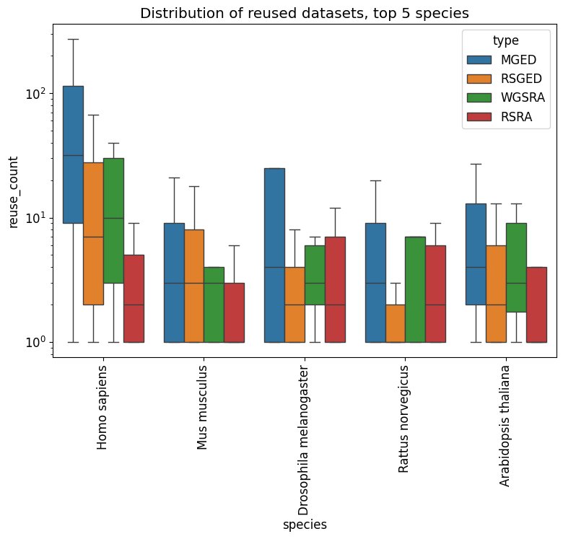
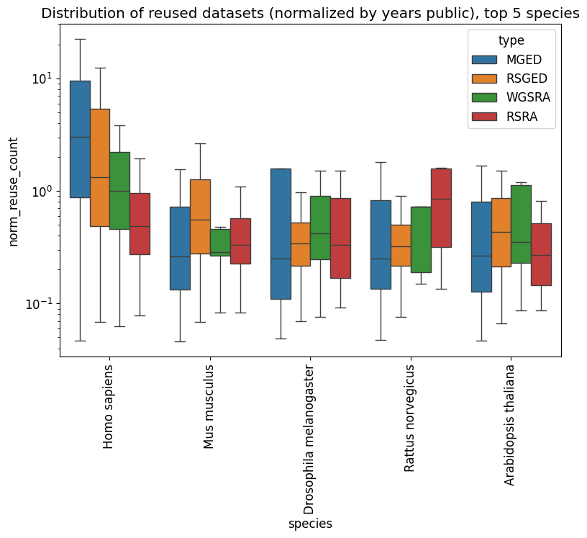

(Figure S5) Distribution of reused datasets for top 5 species. (A) non-normalized by year public, (B) normalize.

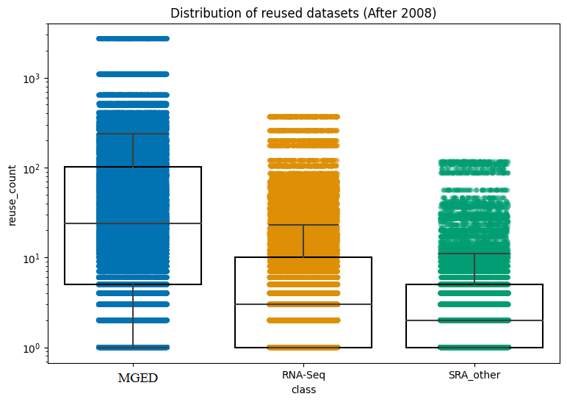

(Figure S6) Reuse distribution of reused datasets after the 2008 public date.

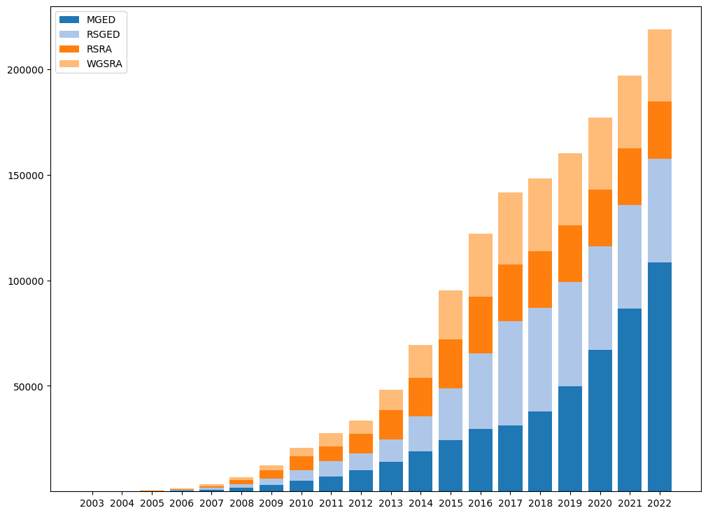
(Figure S7) Yearly breakdown Primary and Secondary analysis for each repository.

References
1. Sayers, E. W. et al. Database resources of the National Center for Biotechnology Information. Nucleic Acids Res. (2020) doi:10.1093/nar/gkaa892.
2. Greene, C. S., Garmire, L. X., Gilbert, J. A., Ritchie, M. D. & Hunter, L. E. Celebrating parasites. Nature genetics vol. 49 483–484 (2017).
3. Rung, J. & Brazma, A. Reuse of public genome-wide gene expression data. Nat. Rev. Genet. 14, 89–99 (2013).
4. Data sharing and the future of science. Nat. Commun. 9, 2817 (2018).
5. Zaritsky, A. Sharing and reusing cell image data. Mol. Biol. Cell 29, 1274–1280 (2018).
6. Sielemann, K., Hafner, A. & Pucker, B. The reuse of public datasets in the life sciences: potential risks and rewards. PeerJ vol. 8 e9954 (2020).
7. Mangul, S. et al. How bioinformatics and open data can boost basic science in countries and universities with limited resources. Nat. Biotechnol. 37, 324–326 (2019).
8. Mangul, S. et al. Using bioinformatics training to boost research capacities in resource-limited regions. doi:10.7287/peerj.preprints.27415.
9. Nudelman, Kelly, Kwangsik Nho, Michael Zhang, Brenna C. McDonald, Wanting Zhai, Brent J. Small, Claire E. Wegel et al. "Genetic variants associated with longitudinal cognitive performance in older breast cancer patients and controls." Cancers 15, no. 11 (2023): 2877.
10. Mangul, Serghei, Lana S. Martin, Ben Langmead, Javier E. Sanchez-Galan, Ian Toma, Fereydoun Hormozdiari, Pavel Pevzner, and Eleazar Eskin. "How bioinformatics and open data can boost basic science in countries and universities with limited resources." Nature biotechnology 37, no. 3 (2019): 324-326.
11. Brito, J. J. et al. Recommendations to enhance rigor and reproducibility in biomedical research. Gigascience 9, (2020).
12. Emmert-Streib, F., Dehmer, M. & Yli-Harja, O. Against Dataism and for Data Sharing of Big Biomedical and Clinical Data with Research Parasites. Front. Genet. 7, 154 (2016).
13. Frazee, A. C., Langmead, B. & Leek, J. T. ReCount: a multi-experiment resource of analysis-ready RNA-seq gene count datasets. BMC Bioinformatics 12, 449 (2011).

14. Khan, N., Pink, C. J. & Thelwall, M. Identifying Data Sharing and Reuse with Scholix: Potentials and Limitations. Patterns vol. 1 100007 (2020).
15. Mahi, N. A., Najafabadi, M. F., Pilarczyk, M., Kouril, M. & Medvedovic, M. GREIN: An Interactive Web Platform for Re-analyzing GEO RNA-seq Data. Sci. Rep. 9, 7580 (2019).
16. Bradley, P., den Bakker, H. C., Rocha, E. P. C., McVean, G. & Iqbal, Z. Ultrafast search of all deposited bacterial and viral genomic data. Nat. Biotechnol. 37, 152–159 (2019).
17. Faria, Matthew, Steve Spoljaric, and Frank Caruso. "Reanalysis: the forgotten sibling of reproducibility and replicability." Nature Reviews Methods Primers 2, no. 1 (2022): 14.
18. Casey S. Greene, Dongbo Hu, Richard W. W. Jones, Stephanie Liu, David S. Mejia, Rob Patro, Stephen R. Piccolo, Ariel Rodriguez Romero, Hirak Sarkar, Candace L. Savonen, Jaclyn N. Taroni, William E. Vauclain, Deepashree Venkatesh Prasad, Kurt G. Wheeler. refine.bio: a resource of uniformly processed publicly available gene expression datasets. URL: https://www.refine.bio.
19. Wood-Charlson, Elisha M., Zachary Crockett, Chris Erdmann, Adam P. Arkin, and Carly B. Robinson. "Ten simple rules for getting and giving credit for data." PLOS Computational Biology 18, no. 9 (2022): e1010476.
20. Wang, Charles, Binsheng Gong, Pierre R. Bushel, Jean Thierry-Mieg, Danielle Thierry-Mieg, Joshua Xu, Hong Fang et al. "A comprehensive study design reveals treatment-and transcript abundance–dependent concordance between rna-seq and microarray data." Nature biotechnology 32, no. 9 (2014): 926.
21. Faria, Matthew, Steve Spoljaric, and Frank Caruso. "Reanalysis: the forgotten sibling of reproducibility and replicability." Nature Reviews Methods Primers 2, no. 1 (2022): 14.
22. Lachmann, Alexander, Denis Torre, Alexandra B. Keenan, Kathleen M. Jagodnik, Hoyjin J. Lee, Lily Wang, Moshe C. Silverstein, and Avi Ma’ayan. "Massive mining of publicly available RNA-seq data from human and mouse." Nature communications 9, no. 1 (2018): 1366.
23. Perez-Riverol, Yasset, Andrey Zorin, Gaurhari Dass, Manh-Tu Vu, Pan Xu, Mihai Glont, Juan Antonio Vizcaíno et al. "Quantifying the impact of public omics data." Nature Communications 10, no. 1 (2019): 3512.
24. Garabík, Radovan. "Processing XML text with Python and ElementTree–a practical experience." Bratislava, Ľ. Štúr Institute of Linguistics (2005).
25. Mangul, Serghei, Harry Taegyun Yang, Nicolas Strauli, Franziska Gruhl, Hagit T. Porath, Kevin Hsieh, Linus Chen et al. "ROP: dumpster diving in RNA-sequencing to find the source of 1 trillion reads across diverse adult human tissues." Genome biology 19 (2018): 1-12.
26. Allen, M. The SAGE Encyclopedia of Communication Research Methods. (SAGE Publications, Inc, 2017). doi:10.4135/9781483381411.
27. Data sharing and the future of science. Nat Commun 9, 2817 (2018).
28. Greene, C. S., Garmire, L. X., Gilbert, J. A., Ritchie, M. D. & Hunter, L. E. Celebrating parasites. Nat Genet 49, 483–484 (2017).
29. Bai, Yongmei, and Jian Du. "Measuring the impact of health research data in terms of data citations by scientific publications." Scientometrics 127, no. 12 (2022): 6881-6893.
30. Longo, Dan L., and Jeffrey M. Drazen. "Data sharing." New England Journal of Medicine 374, no. 3 (2016): 276-277.
31. Greene, C. S., Garmire, L. X., Gilbert, J. A., Ritchie, M. D. & Hunter, L. E. Celebrating parasites. Nature genetics vol. 49 483–484 (2017).

